Authors' Instructions for the preparation of IxD&A's papers.
Carlo Giovannella,4, Sabine Graf², Patrizia Marti³, Andrea Camusi 1,

1 Scuola IaD, Università di Roma Tor Vergata, Via O. Raimondo 18,
00173 Rome, Italy
2 School of Computing and Information Systems, Athabasca University, Canada
3 Communication Science Dept, University of Siena, Via Roma 56,
53100 Siena, Italy
4 ISIM_garage Phys Dept., Università di Roma Tor Vergata, Via della ricerca scientifica 1,
00133 Rome, Italy
{giovannella, camusi}@scuolaiad.it
Abstract. The abstract should summarize the contents of the paper and should contain at least 70 and at most 150 words. It should be set in 9-point font size and should be inset 1.0 cm from the right and left margins. There should be two blank (10-point) lines before and after the abstract. This document is in the required format.
Keywords: We would like to encourage you to list your keywords in this section.

1 Introduction
This instruction file for Word users may be used as a template. Kindly upload the final and checked editable file of your paper into the paper management system of IxD&A. It is not possible to update files at a later stage. Please note that we do not need the printed paper.
We would like to draw your attention to the fact that it is not possible to modify a paper in any way, once it has been published. This applies to both the printed book and the online version of the publication. Every detail, including the order of the names of the authors, should be checked before the paper is uploaded.

1.1 Additional Information Required by the Volume Editor
If you have more than one surname, please make sure that the Editor knows how you are to be listed in the author index.

1.2 Copyright Forms
The copyright form may be downloaded from the About IxD&A-Doc (download) section of the IxD&A Website: www.scuolaiad.it/IxDEA/. Please send your signed copyright form to the Editor, either as a scanned pdf. One author may sign on behalf of all of the other authors of a particular paper. Digital signatures are acceptable.

2 Paper Preparation
The printing area is 122 mm × 193 mm. The text should be justified to occupy the full line width, so that the right margin is not ragged, with words hyphenated as appropriate. Please fill pages so that the length of the text is no less than 180 mm, if possible.
Use 10-point type for the name(s) of the author(s) and 9-point type for the address(es) and the abstract. For the main text, please use 10-point type and single-line spacing. We recommend the use of Computer Modern Roman or Times. Italic type may be used to emphasize words in running text. Bold type and underlining should be avoided.
Papers not complying with the present guidelines will be reformatted. This can lead to an increase in the overall number of pages. We would therefore urge you not to squash your paper.
Headings. Headings should be capitalized (i.e., nouns, verbs, and all other words except articles, prepositions, and conjunctions should be set with an initial capital) and should, with the exception of the title, be aligned to the left. Words joined by a hyphen are subject to a special rule. If the first word can stand alone, the second word should be capitalized. The font sizes are given in Table 1.
Table 1. Font sizes of headings. Table captions should always be positioned above the tables.
Heading level | Example | Font size and style
Title (centered) | Lecture Notes … | 14 point, bold
1st-level heading | 1 Introduction | 12 point, bold
2nd-level heading | 2.1 Printing Area | 10 point, bold
3rd-level heading | Headings. Text follows … | 10 point, bold
4th-level heading | Remark. Text follows … | 10 point, italic

Lemmas, Propositions, and Theorems. The numbers accorded to lemmas, propositions, and theorems, etc. should appear in consecutive order, starting with Lemma 1, and not, for example, with Lemma 11.

2.1 Figures
Please check that the lines in line drawings are not interrupted and have a constant width. Grids and details within the figures must be clearly legible and may not be written one on top of the other. Line drawings should have a resolution of at least 800 dpi (preferably 1200 dpi). The lettering in figures should have a height of 2 mm (10-point type). Figures should be numbered and should have a caption which should always be positioned under the figures, in contrast to the caption belonging to a table, which should always appear above the table. Please center the captions between the margins and set them in 9-point type (Fig. 1 shows an example). The distance between text and figure should be about 8 mm, the distance between figure and caption about 6 mm.
To ensure that the reproduction of your illustrations is of a reasonable quality, we advise against the use of shading. The contrast should be as pronounced as possible.
If screenshots are necessary, please make sure that you are happy with the print quality before you send the files.
Remark 1. In the printed volumes, illustrations are generally black and white (halftones), and only in exceptional cases, and if the author is prepared to cover the extra costs involved, are colored pictures accepted. Colored pictures are welcome in the electronic version free of charge. If you send colored figures that are to be printed in black and white, please make sure that they really are legible in black and white. Some colors show up very poorly when printed in black and white.
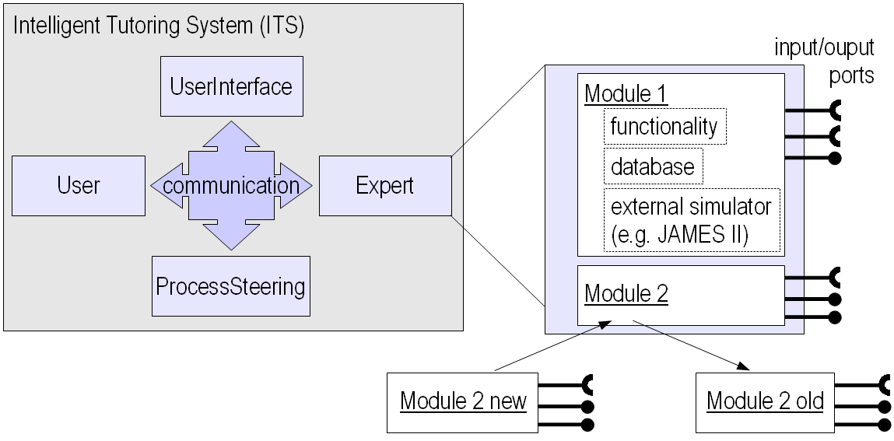
Fig. 1.. Elements of the figure described in the caption should be set in italics, in parentheses, as shown in this sample caption.

2.2 Formulas
Displayed equations or formulas are centered and set on a separate line (with an extra line or halfline space above and below). Displayed expressions should be numbered for reference. The numbers should be consecutive within each section or within the contribution, with numbers enclosed in parentheses and set on the right margin.
A² + B = C . | ()

Equations should be punctuated in the same way as ordinary text but with a small space before the end punctuation mark.

2.3 Footnotes
The superscript numeral used to refer to a footnote appears in the text either directly after the word to be discussed or – in relation to a phrase or a sentence – following the punctuation mark (comma, semicolon, or period). Footnotes should appear at the bottom of the normal text area, with a line of about 5cm set immediately above them.

2.4 Program Code
Program listings or program commands in the text are normally set in typewriter font, e.g., CMTT10 or Courier.

[...]
if (pc.pfss.cb04.isSelected())
{
t_isto.magnif_factor = pc.pfss.siclasswid.getValue();
saccadi_isto.magnif_factor = pc.pfss.siclasswid.getValue();
t_isto.mostra(pstat1f,fs1f,dim_fs1xf, dim_fs1yf);
saccadi_isto.mostra(pstat1s,fs1s,dim_fs1xs, dim_fs1ys);
}

if (pc.pfss.cb01.isSelected())
{
x_isto.magnif_factor = pc.pfss.simagfac.getValue();
y_isto.magnif_factor = pc.pfss.simagfac.getValue();
d_isto.magnif_factor = pc.pfss.siclasswid.getValue();
x_isto.mostra(pstat2x,fs2x,dim_fs2xx, dim_fs2yx);
y_isto.mostra(pstat2y,fs2y,dim_fs2xy, dim_fs2yy);
d_isto.mostra(pstat2d,fs2d,dim_fs2xd, dim_fs2yd);
}
[...]

2.5 Citations
For citations in the text please use square brackets and consecutive numbers: [1], [2], [3], etc.

2.6 Page Numbering and Running Heads
There is no need to include page numbers. If your paper title is too long to serve as a running head, it will be shortened. Your suggestion as to how to shorten it would be most welcome.

Acknowledgments. The heading should be treated as a 3rd level heading and should not be assigned a number.

3 The References Section
Please base your references on the examples below. References that don’t adhere to this style will be reformatted. You should therefore check your references carefully. The reference section must be complete. You may not omit references. Instructions as to where to find a fuller version of the references are not permissible.
We only accept references written using the latin alphabet. If the title of the book you are referring to is in Russian or Chinese, then please write (in Russian) or (in Chinese) at the end of the transcript or translation of the title.
The following section shows a sample reference list with entries for journal articles [1], a book chapter [2], a book [3], proceedings without editors [4] and [5], as well as a URL [6]. Please note that proceedings are not cited with their full titles, but with their acronyms!

References
1. Viola S.R., Graf S., Kinshuk, Leo T.: Analysis of Felder-Silverman Index of Learning Styles by a Data-driven Statistical Approach, International Journal of Interactive Technology and Smart Education, 4, pp. 7--18 (2007)
2. Giovannella C., Spadavecchia C., Camusi A.: Educational complexity: centrality of design and monitoring of the experience, in USAB 2010, LNCS, vol. 6389, pp. 353--372, Springer, Heidelberg, (2010)
3. Callois R.: Man, Play and Games, First Illinois, (2001) (1958)
4. Himmelspach, J., Uhrmacher, A.M.: Plug'n simulate. In: Proceedings of the 40th Annual Simulation Symposium, pp. 137--143. IEEE Computer Society (2007)
5. Picard, R.W.: Affective computing M.I.T Media Laboratory Perceptual Computing Section Technical Report No. 321. November (1995)
6. LIFE, http://life.mifav.uniroma2.it/

Checklist of Items to be Sent to Volume Editors
- A final Word or RTF file
- A final PDF file
- A copyright form, signed by one author on behalf of all of the authors of the paper
- A readme giving the name and email address of the corresponding author

Please note that it is assumes that all authors have used the western naming convention, with given names preceding surnames. This determines the structure of the names in the running heads and the author index.
The footnote numeral is set flush left and the text follows with the usual word spacing.

